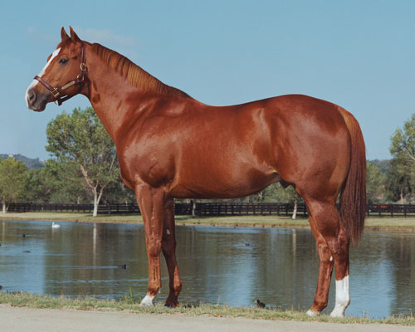
First Down Dash was the most successful sire in Quarter Horse Racing History. Bred by A. F. Stanley Jr. and B. F. Philips in 1984 out of the Gallant Jet mare; Owned by the Vessels family and standing stud at the Vessels Stallion Farm in Bonsall, California. First Down Dash sired the earners of over $85 million and 35 champions since his first progeny began racing in 1991. First Down Dash has made an irrefutable impact on the racing industry producing 249 stakes winners and 1,366 1st place racing wins. Six All American Futurity winners have been sired by First Down Dash. On the track First Down Dash won 13 of 15 starts as a two year old under the training of Mike Robbins. Horse Racing’s most prominent sire died on Thanksgiving Day, November 25th 2010 at the Vessels Stallion Farm at the age of 26. First Down Dash was honored and inducted into the American Quarter Horse Hall of Fame in 2011.

